PROJECT DOCUMENTATION
By
Devi Sree Dornala,
Jyothi Swaroop Kumar Jammula
Kaushalkumar Dineshbhai Sharma
Divyasri Harshita Sriram
Asritha Thota

Contents
INTRODUCTION 3
Purpose 3
About the Art Dealer Game 3
PROCESS MODEL 4
Process Flow Explanation 5
USE CASES 6
UML Model & Class Diagram 7
User Experience Design 10
Personas 10
UI MOCK UP 11
TESTING STRATEGY 13
CONCLUSION 14

INTRODUCTION

Purpose
This report is a comprehensive description of the design, development, and testing of the Art Dealer Game, an educational simulation created in Python and Tkinter. It is aimed at educators, students and developers who want to know the objectives, architecture and learning outcomes of the system.
The main aim of this documentation is to introduce the purpose of the game, learning value and how the game will be implemented in a clear and organized way. The document is written in a lightweight Agile-inspired format with an emphasis on the key information that helps to understand, reproduce, and make the document better.
This will make sure that the focus is on what really counts, which is to provide young learners with a fun, interactive and pedagogically significant experience and at the same time have a software design that is maintainable and extensible.

About the Art Dealer Game
The Art Dealer Game is a teaching card game of logic and pattern recognition aimed at students in Kindergarten to Grade 8 (K8). It assists students in enhancing their reasoning, pattern recognition, and logical thinking in mathematics by learning through play.
The game is played as a simulation of a situation in which the student is the gallery owner (or a seller), and the computer is the art dealer who follows a pattern to purchase particular cards secretly. The student will be required to experiment with four cards of a set of twelve cards displayed and note the cards that the dealer purchases. According to this feedback, the student develops hypotheses and attempts to guess the concealed pattern based on a list.

When the student makes a correct guess, he/she wins the round and receives animations and positive feedback. Otherwise, the game will give them progressive hints to follow their line of reasoning.
The game has three difficulty levels to suit the various age groups:
K-2: Patterns involving visual and color (e.g., all red cards, same suit).
3-5: Patterns involving numbers and logic (e.g., prime numbers, sum equals 9).
6-8: Higher mathematical and logical combinations (e.g. straights, flushes, four-of-a-kind).
The interface is deliberately made with big buttons, vivid graphics and easy feedback, which makes it easy to use even by young children who have little computer knowledge. Sound effects and animations are optional and allow the user to be more engaged without being too difficult to use..

PROCESS MODEL
The Art Dealer Game was developed using an Agile–Evolutionary Process Model, which blends the adaptability of Agile methods with the structured improvement cycle of the Spiral Model. This approach was chosen because the target users—children from Kindergarten to Grade 8—require constant usability refinement, ensuring the game is both educational and engaging.
Instead of attempting to design the entire game in a single phase, development progressed through incremental, feedback-driven iterations. Each iteration produced a playable prototype that was tested, evaluated, and refined based on user feedback before advancing to the next stage.
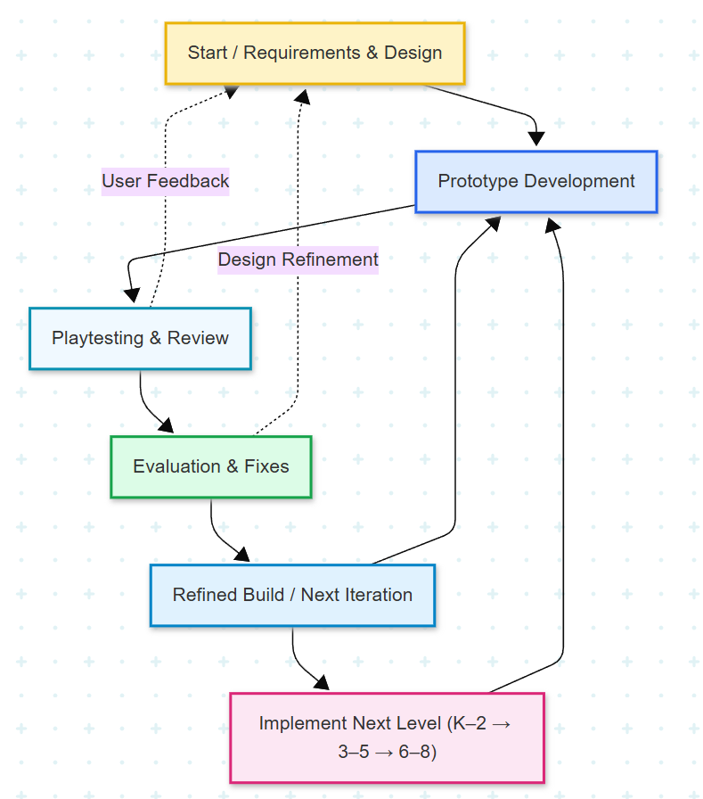
Figure 1 Agile–Evolutionary Process Model for the Art Dealer Game

Process Flow Explanation
The workflow starts with the Requirements and Design stage as shown in Figure 2.1 -Agile-Evolutionary Process Model where the gameplay goals, grade-specific learning outcomes, and interface requirements were outlined. After the base was laid, the team transitioned to Prototype Development where they created an early version of the game in Python and Tkinter.
Playtesting and Review followed, during which informal user testing (facilitated by the personas Liam, Sophia, and Jayden) was used to determine usability and engagement problems. These sessions were observed and used to inform the Evaluation & Fixes phase, where gameplay logic, UI clarity, and error handling were made better.
Following every evaluation cycle, a Refined Build was created and re-tested, and a Next Iteration was created that added the next level of complexity. As an illustration, the initial cycle used the K-2 visual patterns, the second cycle incorporated 3-5 numerical patterns and the last cycle incorporated 6-8 advanced logic patterns.
User feedback and design refinement were used in continuous feedback loops throughout the process, allowing rapid adaptation and avoiding usability regressions. This process was learner-centered and iterative in nature, which made the final product to be intuitive, robust, and developmentally appropriate across all grade levels.

USE CASES
The Art Dealer Game is an interactive educational application where students explore card patterns and reasoning through guided gameplay. Each use case below describes a primary interaction between the student (player) and the system (Art Dealer Game). These use cases ensure all user interactions—from starting the game to winning a round—are captured and clearly defined.
UC | UC Name | Actor | Precondition | Description & Normal Flow | Expected Outcome
UC1 | Select Level | Student | The game application is running. | 1. The system displays a level selection screen.2. The student selects a grade level (K–2, 3–5, or 6–8).3. The system loads 12 random cards and a secret pattern for that level. | The game initializes the chosen level and displays the first round.
UC2 | Pick Cards | Student | A level has been selected and 12 cards are displayed. | 1. The student selects up to four cards from the table.2. The system highlights the selected cards and ensures no more than four are chosen. | Four cards are visually highlighted as the student’s selection.
UC3 | Submit Cards | Student | Four cards have been selected. | 1. The student clicks “Submit 4 Cards.”2. The system checks which selected cards match the hidden pattern.3. Matching cards are highlighted; non-matching ones reset. | The system provides visual/auditory feedback showing the number of cards bought.
UC4 | Guess Pattern | Student | At least one card submission has been made. | 1. The student selects a pattern name from the dropdown.2. The system compares it to the secret pattern.3. If correct → the player wins.4. If incorrect → the system decreases remaining guesses and shows a hint. | Correct → “You Win” message; Incorrect → updated guesses and hint displayed.
UC5 | Get a Hint | Student | A round is in progress. | 1. The player clicks the “Hint” button (or automatically receives one after a wrong guess).2. The system displays a clue related to the hidden pattern (e.g., “Think about color”). | A helpful hint appears, guiding the player toward the correct pattern.
UC6 | Play Again / Exit | Student | A game round has ended (win or loss). | 1. The system displays options: “Play Again,” “Change Level,” or “Exit.”2. The player selects an option.3. The game restarts or closes accordingly. | The system executes the chosen option — either restarting or exiting the game.

UML Model & Class Diagram
This diagram shows how the student, who is the main user of the Art Dealer Game, interacts with the system. The student is shown as a rectangle on the left, and all the possible actions (called use cases) are shown as ovals on the right inside a group called “Use Cases.”
Each line from the student to a use case shows something the student can do in the game:
- Select Level: Pick a grade level (K–2, 3–5, or 6–8)
- Pick Cards: Choose 4 cards from the screen
- Choose Pattern: Select a pattern from the list
- Submit Guess: Submit the guess and check if it's correct
- Use Hint: Ask for a hint if unsure
- Play Again or Exit: Restart or close the game
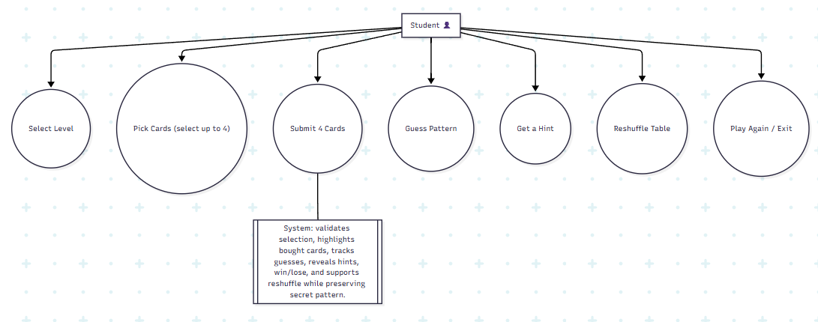
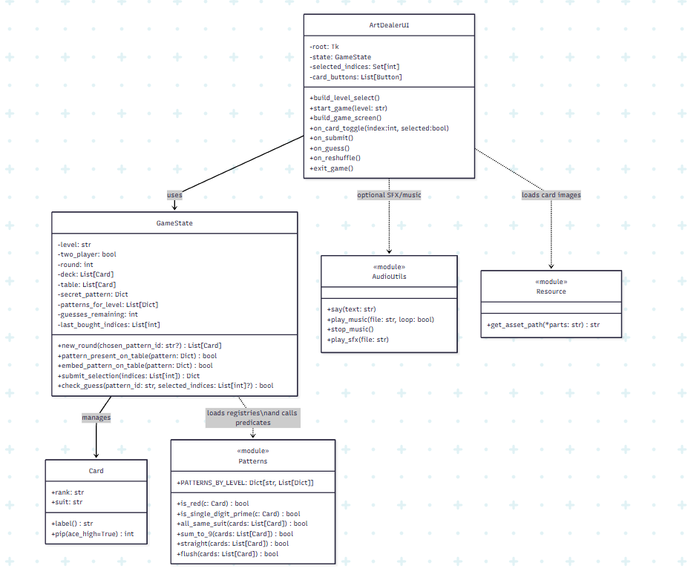
Figure 2 Primary interactions between the Student and the Art Dealer Game
Figure 3 Modules and relationships in the implementation.

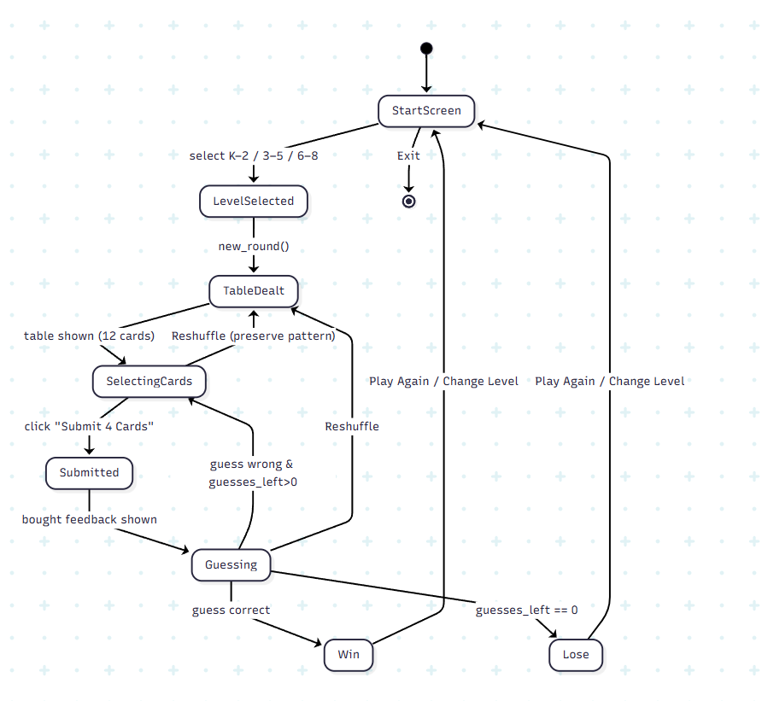
Figure 4 Runtime states from launch to win/lose and replay.

The class diagram for the Art Dealer Game illustrates the structural design of the system by outlining the main components and their relationships. The central controller of the application is the GameController class, which manages the game logic, player actions, and state transitions. It utilizes the Button class to handle all interactive UI elements, and calls functions from the GameLogic module to select patterns and evaluate player guesses. Each class is defined with relevant attributes (such as deck, selected_cards, and callback) and methods (like submit_cards() or is_clicked(pos)) that support clean modular development. The diagram emphasizes how the main controller interacts with the user interface and the backend logic in a structured, object-oriented way.

User Experience Design
The Art Dealer Game is designed around a child-friendly, exploratory learning experience, where students interact with playing cards to discover logical or visual patterns.
The interface follows the principles of simplicity, visibility, and feedback, ensuring that even early-grade students can operate the game independently while older students remain challenged by progressively complex rules.
The design focuses on:
- Minimal text, relying instead on clear icons, colors, and visual responses.
- Consistent layout, with cards arranged in a 3 × 4 grid for familiarity.
- Immediate feedback, using color highlights, animations, and optional sounds.
- Accessibility, providing large clickable areas and clear visual contrast.

Personas
Persona | Age / Level | Background & Motivation | Goals | Challenges Addressed by the Game
Liam – The Explorer | 6 years (K–2) | Curious first-grader beginning to recognize numbers and colors. | Learn through play; spot visual similarities; enjoy bright visuals. | Complex rules overwhelm him — the simple red/black and suit patterns help him succeed easily.
Sophia – The Thinker | 10 years (3–5) | Elementary student comfortable with basic arithmetic and logic puzzles. | Identify numeric or logical relationships; understand cause-effect between card choices and dealer responses. | Needs clear visual feedback to connect actions with results — receives progressive hints after wrong guesses.
Jayden – The Strategist | 13 years (6–8) | Middle-schooler interested in reasoning games. | Tackle advanced sets like “straight” or “four of a kind”; apply logical deduction. | Wants challenge; benefits from more complex levels and reduced guidance.

UI MOCK UP
Principle | Implementation in Art Dealer Game
Simplicity & Clarity | One main screen per phase (Level Select → Game → Results). Large fonts and clear contrast ensure readability.
Error Tolerance | Limits selections to four cards and disables invalid actions to prevent frustration.
Immediate Feedback | Bought cards flash green; wrong guesses trigger sound and hints. Reinforces learning by showing cause → effect.
Consistency | Uniform color scheme, consistent button placement, and same navigation flow across levels.
Progressive Difficulty | K–2: visual; 3–5: numeric; 6–8: logical. Supports incremental skill growth.
Accessibility | Large clickable areas, readable color palette, optional sound for non-readers.
Engagement | Visual animations, positive sound cues, and “win” dialogs to reward discovery.

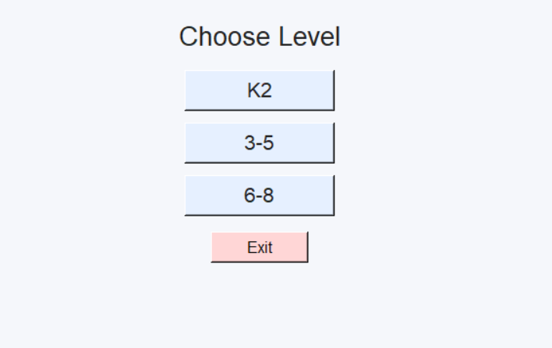
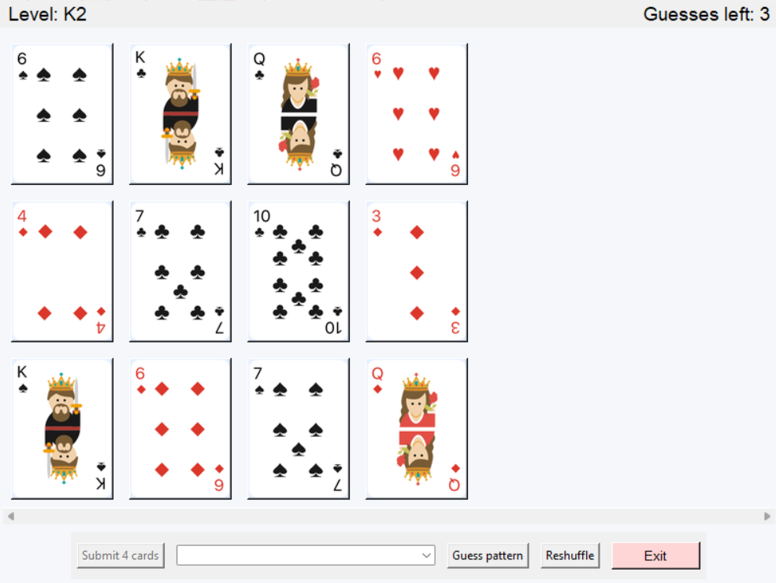
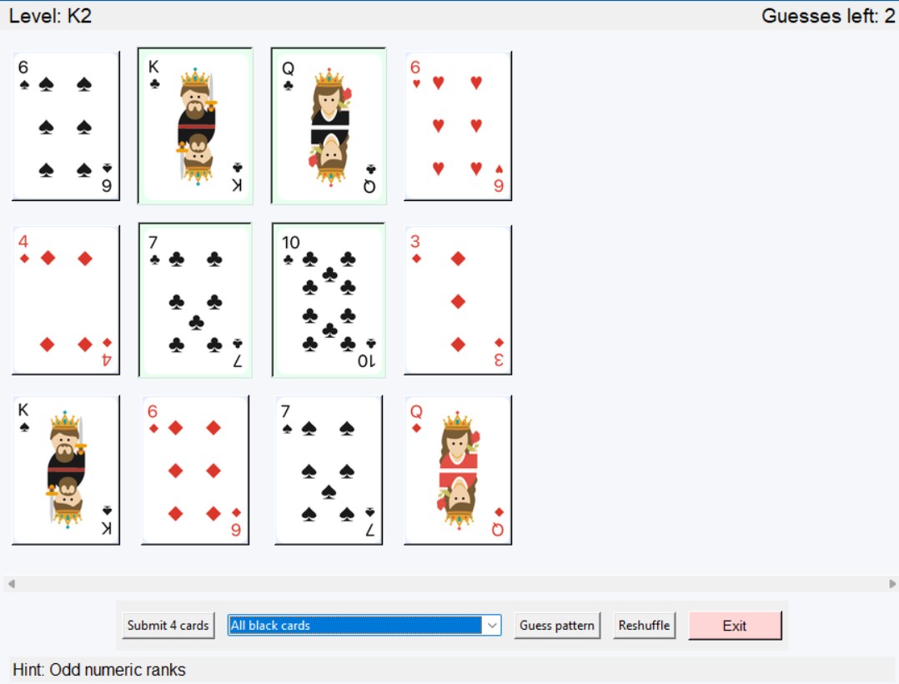
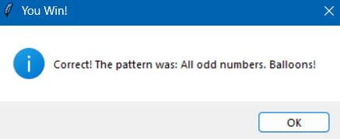

TESTING STRATEGY
The Art Dealer Game testing was conducted in an iterative way during the development process, according to the Agile-Evolutionary model. Every development phase, such as core logic development to user interface development, was followed by several levels of testing to verify accuracy, usability and stability. The testing strategy encompassed four significant types, which include Unit Testing, Integration Testing, Usability Testing, and Validation Testing.
Unit Testing was done to test each module separately to ensure that individual functions and classes worked as expected. Patterns.py functions were tested to ensure that predicates like is red, sum to 9 and two pairs gave the right answers. The Card and GameState classes were also tested to make sure that card labels, deck generation and table initiation were error free. These tests ensured that all individual components were stable and resistant to invalid inputs, including empty decks or out-of-range selections.
Integration Testing was then conducted to make sure that there was a smooth coordination between the game logic, user interface and pattern modules. The testing confirmed that the GameState object properly interacted with the ArtDealerUI, and that UI actions, including the selection of cards, the submission of guesses, or the reshuffling, were properly responded to by logic. Integration testing was also used to ensure that the optional audio utilities (audio_utils.py) did not cause the application failures in case of unavailability of sound files or dependencies. The system was very stable in all interactions.
Then, Usability Testing was performed to determine the efficiency and understandability of the user experience, particularly in the case of the target audience of K-8 students. The user personas of Liam (K-2), Sophia (3-5) and Jayden (6-8) were used to simulate playtesting. These sessions were aimed at the ease with which players could choose cards, comprehend feedback, and detect patterns. It was observed that visual highlights, sound cues, and clear hint messages were much more effective in enhancing engagement and understanding. Small usability problems like accidental exits were spotted early and fixed by refinements in the interface.
Lastly, the Validation Testing was done to make sure that the final game fulfilled all the functional and educational needs. All significant features were confirmed: the 12-card display, four-card selection rule, pattern-matching logic, hint system, and limited number of guesses. Mechanisms of reshuffling and restart were also tested to ensure that they did not change the secret pattern. The last build was done consistently in all test situations and proved the game to be correct, robust and educational.
Test Category | Objective | Key Focus Areas | Result
Unit Testing | Verify correctness of individual functions and classes. | Tested Card, GameState, and all pattern predicates. | All unit tests passed.
Integration Testing | Ensure smooth communication between UI and logic modules. | Validated ArtDealerUI, GameState, and audio interactions. | Modules integrated seamlessly.
Usability Testing | Assess clarity and accessibility for students (K–8). | Observed user personas during gameplay; evaluated feedback comprehension. | High engagement and ease of use.
Validation Testing | Confirm compliance with functional and learning objectives. | Verified gameplay rules, hints, and reshuffle logic. | Fully meets educational and functional goals.

CONCLUSION
The Art Dealer Game has managed to prove that technology and game-based learning can be integrated to provide an exciting, learning experience to students in Kindergarten to Grade 8. The game allows the players to investigate patterns in an interactive way and develop their cognitive and analytical abilities through the combination of logic, mathematics, and visual reasoning.
The project was created in Python and Tkinter and focuses on technical and pedagogical soundness. Every development cycle was an Agile-Evolutionary cycle, which guaranteed constant improvement of the process by testing, feedback, and user observation. The modular architecture GameState, Card, Patterns and ArtDealerUI components make it easy to maintain, scale and even expand to multiplayer or online versions in the future.
Educationally, the game is consistent with the fundamental skills of mathematical thinking:
- K-2 students are concerned with color and suit recognition and they become aware of patterns.
- Grades 3-5 advance to arithmetic and logical patterning.
- Grades 6-8 are introduced to set-based logic of strategic reasoning similar to probability and combinations of cards in the real world.
The interface was well designed to be clear, accessible, and engaging. The use of bright images, instant feedback, and user-friendly controls allows playing independently and still enjoying the classroom atmosphere. Sound and animations are optional, and they do not affect performance or usability.
The overall testing ensured that the game works well at all ages and applications. The unit, integration, usability and validation tests were all used to ensure that the system achieves its educational and functional goals. The last application is stable, user-friendly and can be deployed in the classroom or used by individuals.
To sum up, Art Dealer Game represents a compromise between technical perfection and education. It shows that when interactive software is well conceived, it can help to build curiosity, logical thinking, and engagement in young learners, making the process of learning meaningful and enjoyable.

